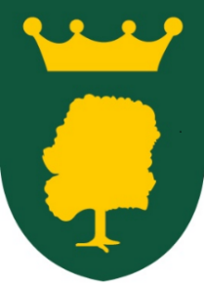

**PAYMENT BY CHILDCARE VOUCHERS**

If you pay for Breakfast or After School Club using Childcare Vouchers it is important that you complete the form below when any payment is made. All payments are to be made on a **half termly basis** and therefore it will be necessary to complete this form each half term. All payments made by Childcare Vouchers should be with either BC or ASC after the child’s name. With the increase in parents using CV it has been very difficult to reconcile school bank accounts.

Thank you for your cooperation.

|  |  |
| --- | --- |
| Child’s Name: | Class: |
| Name of Childcare Voucher Provider: | |
| Date payment made: | |
| What Out of Hours club does this apply to? Please tick  Breakfast Club  After School Club | |
| Amount paid for Breakfast Club: £  Amount paid for After School Club: £  Total Amount Paid: £ | |

Please return this form to Mrs K Coleman